RESOLUTION NO.__________

RE: CERTIFICATE OF APPROPRIATENESS UNDER THE

PROVISIONS OF THE ACT OF THE PENNSYLVANIA

LEGISLATURE 1961, JUNE 13, P.L. 282 (53

SECTION 8004) AND BETHLEHEM ORDINANCE NO.

3952 AS AMENDED.

WHEREAS, it is proposed to replace tile and install window signs at 25 E. ThirdStreet.

NOW, THEREFORE, BE IT RESOLVED by the Council of the City of Bethlehem that a Certificate of Appropriateness is hereby granted for the work.

Sponsored by: (s)

(s)

ADOPTED BY COUNCIL THIS DAY OF

(s)

President of Council

ATTEST:

(s)

City Clerk

HISTORIC CONSERVATION COMMISSION

CASE # 589– It is proposed to replace tile and install window signs at 25 E. ThirdStreet

OWNER/APPLICANT: Ravi and Tara Nagabhyru

The Commission upon motion by Mr. Lader seconded by Mr. Hudak adopted the proposal that City Council issue a Certificate of Appropriateness for the proposed work described herein:

1. The proposal to replace tile and install window signs at 25 E. ThirdStreet was represented by Ravi and Tara Nagabhyru.
2. The damaged and some of the undamaged tile will be replaced to create a new design for the tiled façade and avoid removing all of the existing tile. The design may be revised once the plywood covering the damaged tile is removed and exact conditions known.
3. The damaged aluminum storefront framing will be repaired or replaced in kind.
4. The new frost-proof tile will be 2 x 2 to match the size of the existing tile. The new tile may have a matt finish.
5. The existing border tile will remain next to the terracotta where possible to limit the possible damage to the terracotta.
6. The new grout will match the old as closely as possible.
7. New vinyl window signage will also be installed. The new window signs will be approximately 3’ long and multicolor as shown in the drawings.
8. The new signs will be located at the top of the windows as shown in the rendering.
9. The proposed motion was unanimously approved.

CU: cu

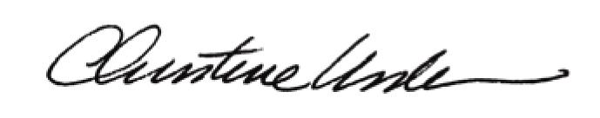

By:

Date of Meeting: May 16, 2016 Title: Historic Officer